# PlanetWars AI Pseudocode

## Game Screenshot

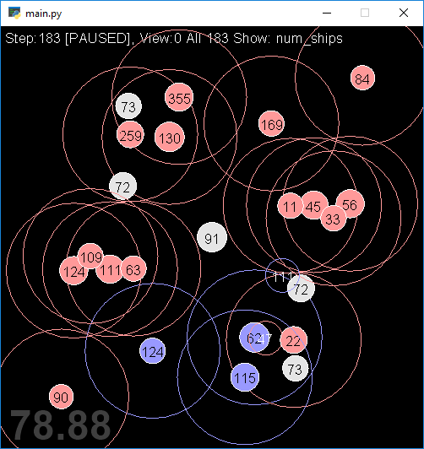

## Rando

Update():

If there’s already a fleet out:

Do nothing

If I have planet(s) and there are planets I don’t control:

Dest = random planet I don’t control

Src = random planet I control

If Src has more than 10 ships:

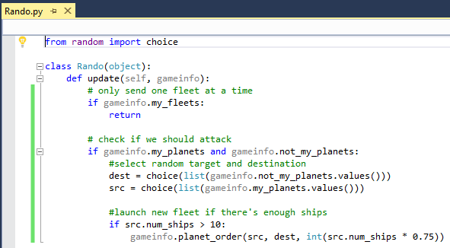 Send 75% of ships from Src to Dest

## Min

Update():

If there’s already a fleet out:

Do nothing

If I have planet(s) and there are planets I don’t control:

Dest = planet I don’t control with the fewest ships

Src = random planet I control

If Src has more than 10 ships:

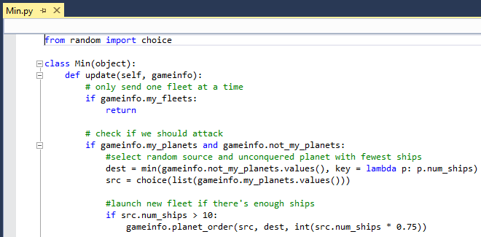 Send 75% of ships from Src to Dest

## Max

Update():

If there’s already a fleet out:

Do nothing

If I have planet(s) and there are planets I don’t control:

Dest = planet I don’t control with the most ships

Src = random planet I control

If Src has more than 10 ships:

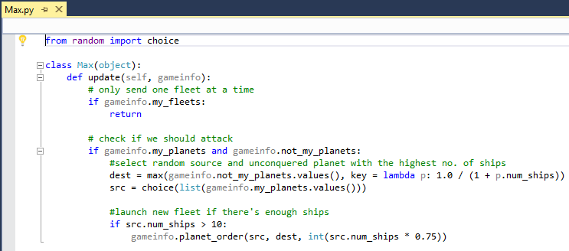 Send 75% of ships from Src to Dest

## NearMin

Update():

If there’s already a fleet out:

Do nothing

If I have planet(s) and there are planets I don’t control:

Dest = planet I don’t control with the fewest ships

Src = ClosestToDest(planets I don’t control, Dest)

If Src has more than 10 ships:

Send 75% of ships from Src to Dest

ClosestToDest(planets, Dest):

For each planet:

If no planet has been selected:

Closest = planet

Distance = planet.distanceTo(Dest)

Else:

newDist = planet.distanceTo(Dest)

if newDist < Dist and no. ships on planet > no. ships on Dest:

Closest = planet

Dist = newDist

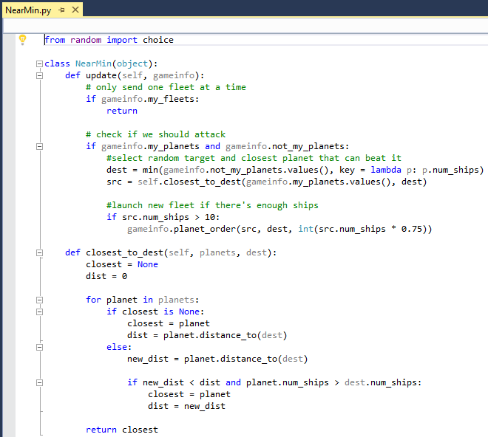 Return Closest

## NearMax

Update():

If there’s already a fleet out:

Do nothing

If I have planet(s) and there are planets I don’t control:

Dest = planet I don’t control with the most ships

Src = ClosestToDest(planets I don’t control, Dest)

If Src has more than 10 ships:

Send 75% of ships from Src to Dest

ClosestToDest(planets, Dest):

For each planet:

If no planet has been selected:

Closest = planet

Distance = planet.distanceTo(Dest)

Else:

newDist = planet.distanceTo(Dest)

if newDist < Dist and no. ships on planet > no. ships on Dest:

Closest = planet

Dist = newDist

Return Closest

